Contents

Abstract 2

Introduction 2

Aim and objectives 3

Design and implementation 3

Components 3

Blynk application 5

Circuit diagram of the connections 7

Conclusion and future work 11

Smart irrigation system

# Abstract

Agriculture is the most important part of the world and irrigation is the most essential part of agriculture. Some part of this world may have excessive water thus not having to deal with irrigation problem however; there are dryer regions that need the saving of water to be able to irrigate their fields in future efficiently. Smart irrigation is the way to save water by providing water to the area where it is only needed and it controls the over flow of water in the filed by stopping the water supply automatically when the field has enough water.

# Introduction

The increase in demand for energy has outpaced power generation. Due to the fast growth in population and industry, power. This calls for demand control to maximize usage of the minimal electricity produced. Irrigation is one of the fields where power is so important. The water tanks always need to pump water to run the irrigation system. However, the existing irrigation schemes do not make effective use of two limited and important irrigation services, i.e., water and electricity. They do not have the resources to determine where and when irrigation is needed therefore, irrigation is often carried out when it is not needed or postponed when necessary. This causes a loss of water/energy and poor soil fertility. Such issues can be solved if the irrigation system is able to decide exactly when and when to irrigate. To resolve this, a lot of study has been conducted. It introduces the implementation of smart agriculture and smart grid technology.

# Aim and objectives

The main aims and objective of smart irrigation system using soil moisture sensor is to be able to know the situation of plants whether they are getting enough moisture from the soil or not. If the plants are getting enough moisture than notification should be given about that and vice versa. The aim is to save water and reduce human involvement in the agriculture sector. It is important to continuously monitor the sensor status and take the necessary action.

# Design and implementation

## Components

The components devices used to design the prototype are Node Mcu, soil moisture sensor, jumper wires, data cable.

Node mcu

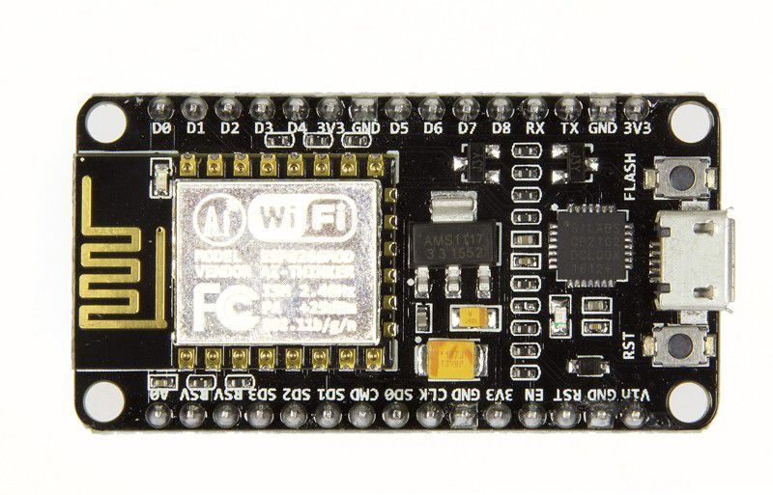

NodeMCU is a firmware built on an open-source LUA created for the Wi-Fi chip ESP8266. NodeMCU firmware comes with the ESP8266 Development board/kit, i.e., by exploring features with the ESP8266 chip. Board of NodeMCU Growth. Since NodeMCU is an open-source framework, edit/modify/build is available for its hardware design.

Soil moisture sensor

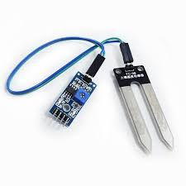

Soil moisture is the water content that is found in the soil. A soil moisture monitor, composed of two conducting probes acting as a probe, may be used to measure this. Based on the change in resistance between the two conducting plates, it can measure the moisture content in the soil.

## Blynk application

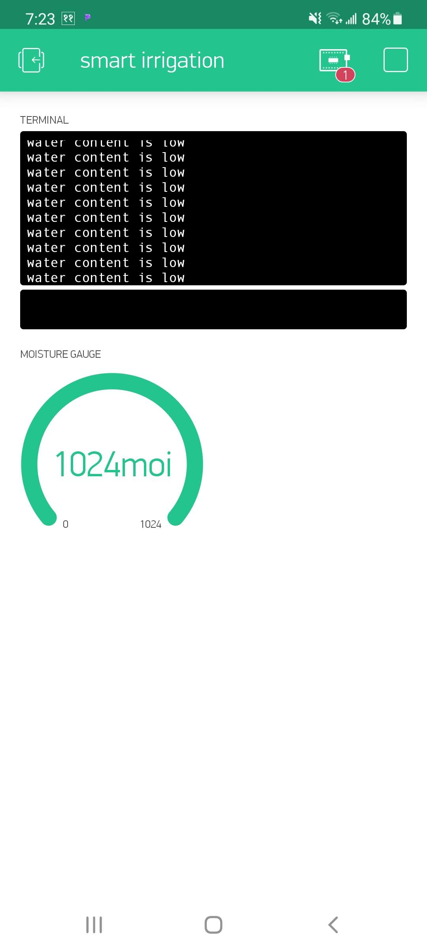

Figure : blynk application showing the current status of soil sensor where water content is low

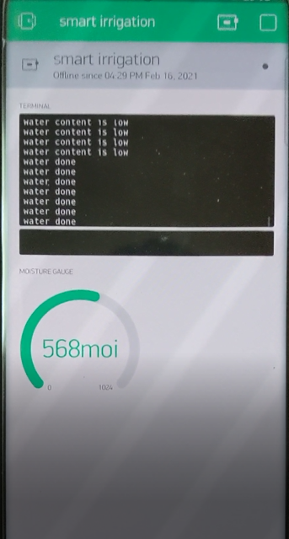

Figure 2: blynk application showing the current status of soil sensor where watering is done

Blynk is a modern framework that allows you to create interfaces easily from your iOS and Android computer to manage and track your hardware projects. We can create a project dashboard on the screen and organize buttons, sliders, graphs and other widgets. You can switch pins on and off or display data from sensors using the widgets. Blynk application is used in this project to display the data coming from the sensor.

Block diagram

**NODE MCU**

**Blynk** **App**

**SOIL** **MOISTURE**

SENSOR

**Plant**

## Circuit diagram of the connections

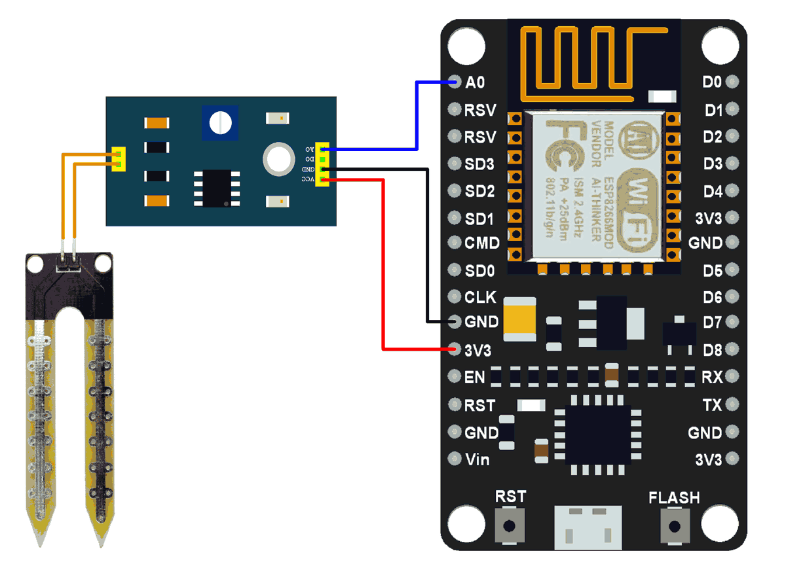

To implement the prototype, soil moisture sensor is connected to the node mcu using jumper wires. A0 pin from sensor is connected to A0 pin of nodemcu. GND pin of sensor is connected to GND of nodemcu and VCC pin of sensor is connected to 3V3 i.e. 3.3 volt of node mcu. Finally, the nodemcu is linked to code to run the program through the data cable. Once the connection is established, the sensor detects the moisture level and gives the notification through blynk application. The application will show if the water content is low or water content is enough. Node mcu and blynk app are provided with the Wi-Fi so that the sensor can read data and display in the application.

The code that was used to implement the project is

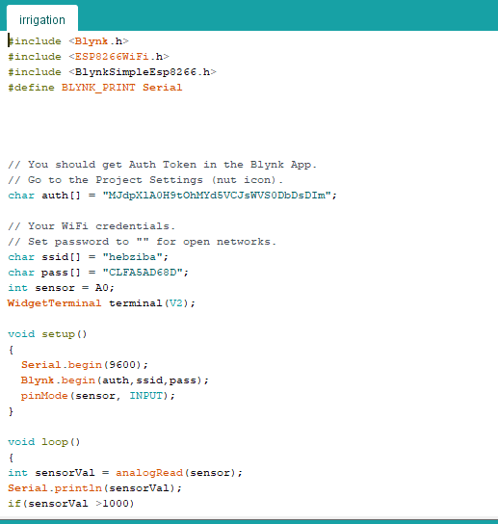

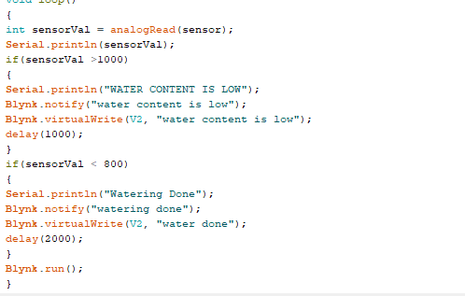

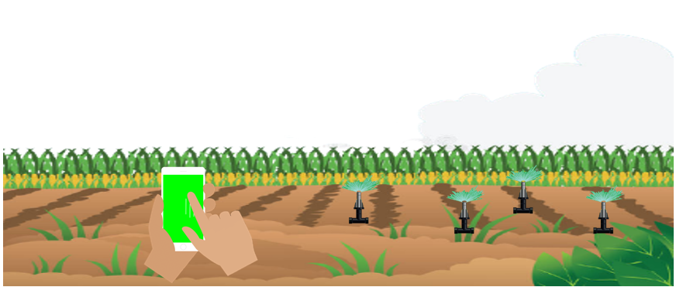

Figure : animated image of the smart irrigation controlled using application.

# Conclusion and future work

To properly manage the consumption of the water and energy we need to minimize its use and to do that we need to have a smart system to determine time and amount of irrigation. This research presents a smart irrigation system that makes decisions on where and when to irrigate within the area it covers. This sort of devolution decreases the irrigation system's difficulty, keeping it more efficient.

In order to grow well, plants require more than just water. This method can be improved in such a way that even soil nutrient knowledge is collected and used to assess the nutrients needed in particular regions of the field, rather than just irrigation control. This is the key focal point for future work.

# Youtube link of the video

https://youtu.be/4DKm3GHrLQg